**2. Wetland mapping using GIS and Remote Sensing**

The delineation of wetland sites of this study followed the methodology described by Wu (2017) and aided by a geographic information system (GIS) and remote sensing tools. Wu’s methodology uses four indicators to identify wetlands[1]. These indicators when overlaid using a GIS environment serve to identify areas within the study areas where the probability of wetland presence is high.

* 1. Wetland Indicators:

2.2.1 Hydrology

Hydrology is one of the most important factors that determines the formation and dynamics of a wetland. In the United States, the hydrology criterion is based on inundated or saturated to the surface for 5% or more of the growing season in most years (from about 7 to 18 days). The uniform criterion for wetland hydrology is a minimum of 14 consecutive days in most years (U.S. Army Corps of Engineers, 2010). In this study, wetland hydrology criteria were documented by monitoring soil saturation and/or inundation of the study sites with observation wells installed and continuously monitored during the study period. The following section describes the Wu’s methodology followed to delineate the wetland areas of the study sites:

Normalized Difference Water Index (NDWI)

The wetlands are an essential hydrologic landscape unit. The formation, persistence, seize and function of wetlands are controlled by hydrologic processes (Carter, 1999). For this case, the hydrology indicator is derived from remotely sensed image data, using the Normalized Difference Water Index (NDWI) presented by McFeeters (1996). The NDWI follows the same principle as the Normalized Difference Vegetation Index (NDVI) based on the reflectance of certain features in specific parts of the electromagnetic spectrum.

The NDWI is computed using the formula:

where GREEN is a band that encompasses reflected green light and NIR represents reflected near-infrared radiation. The result of this equation is in a multispectral satellite image of water features with positive values, and soil and terrestrial vegetation features with zero or negative values (McFeeters, 1996). The NWDI values range from -1 to +1, where the values closest to +1 indicate water or high soil moisture areas (Wu, 2017).

2.2.2 Hydric soils

The National Resources Conservation Service (NRCS) defines hydric soils as soils formed under conditions of saturation, flooding or ponding long enough during the growing season to develop anaerobic conditions in the soil’s upper part layer (NRCS, 2012).

Hydric soils are all map units that have at least one map unit component that is hydric. The criteria for categorizing as hydric are:

* All Histels except Folistels and Histosols except Folists.
* Map unit components in Aquic suborders, great groups, or subgroups; Albolls suborder, Historthels great group, Histoturbels great group, or Andic, Cumulic, Pachic, or Vitrandic subgroups.
* Map unit components that are frequently ponded for long duration or very long duration during the growing season.
* Map unit components that are frequently flooded for long duration or very long duration during the growing season (NRCS, 2012).

Hydric soils spatial data was obtained from the Soil Survey Geographic Database (SSURGO), which consists of spatial data (map unit polygons) and tabular data. The attribute table field called “*hydclprs*” (Hydric Classification – Presence) indicates the proportion of the map unit that is hydric (Wu, 2017).

1. Topographic position

The topography is one of the most important controllers on spatial variation of hydrological conditions. The topographic attributes can be divided into primary and secondary topographic indexes. The first are those obtained directly from the elevation data, and the second ones are combinations of the primary indexes to describe the spatial variability of specific processes (Mattivi et al., 2019).

The Topographic Wetness Index (TWI), which quantifies the tendency of a grid cell to receive and accumulate water in the landscape, is used to determine the topographic position of each wetland site considered in this study. The TWI combines local upslope contributing area and slope to quantify topographic control on hydrological processes (Sorensen et al., 2006), and is defined as:

.

where SCA is the Specific Catchment Area and Φ is the slope angle of the receiving cell, assuming the properties of the soil as uniform. SCA is also called flow accumulation or the number of cells that contribute flow to the receiving cell. The TWI concept is a mass-balance, SCA is a parameter of tendency to receive water (contributing area), and the local slope and the draining contour length, describe the tendency to evacuate water (Mattivi et al., 2019).

A TWI values represent areas prone to water accumulation, while the low TWI values are associated to well-drained or dry areas (steep slopes). The SCA determines the size of the upslope area draining into a cell. A flow routing algorithm is used to understand how the water flows on the land surface (Mattivi et al., 2019).

1. Methods

Definition of study areas

The sub-basin (s) that contained the wetlands centroids of the project, and/or the sub-basin (s) that interacts directly with the water system was defined as study areas. The corresponding sub-basin or sub-basins for each wetland are presented in Table 1 and Figure 1.

Table 1. Study wetlands and their respective sub-basins and centroids.

|  |  |  |  |  |
| --- | --- | --- | --- | --- |
| Wetland | Site Code | Sub-basins (HU-12)[2] | Latitude | Longitude |
| Arroyo1 | AR | Coastal watersheds West and East of río Nigua Mouth. | 17.963560 | -66.043074 |
| Canóvanas | CA | Rio Grande de Loiza (Norte). | 18.380443 | -65.886776 |
| Esperanza B | LE | Rio Grande de Manatí at mouth | 18.465542 | -66.503300 |
| Finca Virginia | FV | Laguna San Jose, Laguna Torrecilla, laguna Piones. | 18.416461 | -65.911744 |
| Laguna Cartagena | LC | Western Valle de Lajas | 18.012453 | -67.109082 |
| Palmas del Mar | PDM | Río candelero at mouth | 18.092804 | -65.800940 |
| Pasto Viejo | PV | Río Anton Ruíz near mouth (west). | 18.160804 | -65.777437 |
| Coastal water between río Humacao and río Santiago. (East) |
| Rio Grande | RG | Costal watersheds between rio Sanaba and rio Grande de Loiza | 18.399278 | -65.825162 |
| PR-3 | PR3 | 18.379994 | -65.748757 |
| Laguna Tortuguero | LT | Rio Cubuco-Cienaga Prieta- laguna Tortuguero | 18.469074 | -66.452310 |
| El Manantial | EM | 18.468492 | -66.423153 |

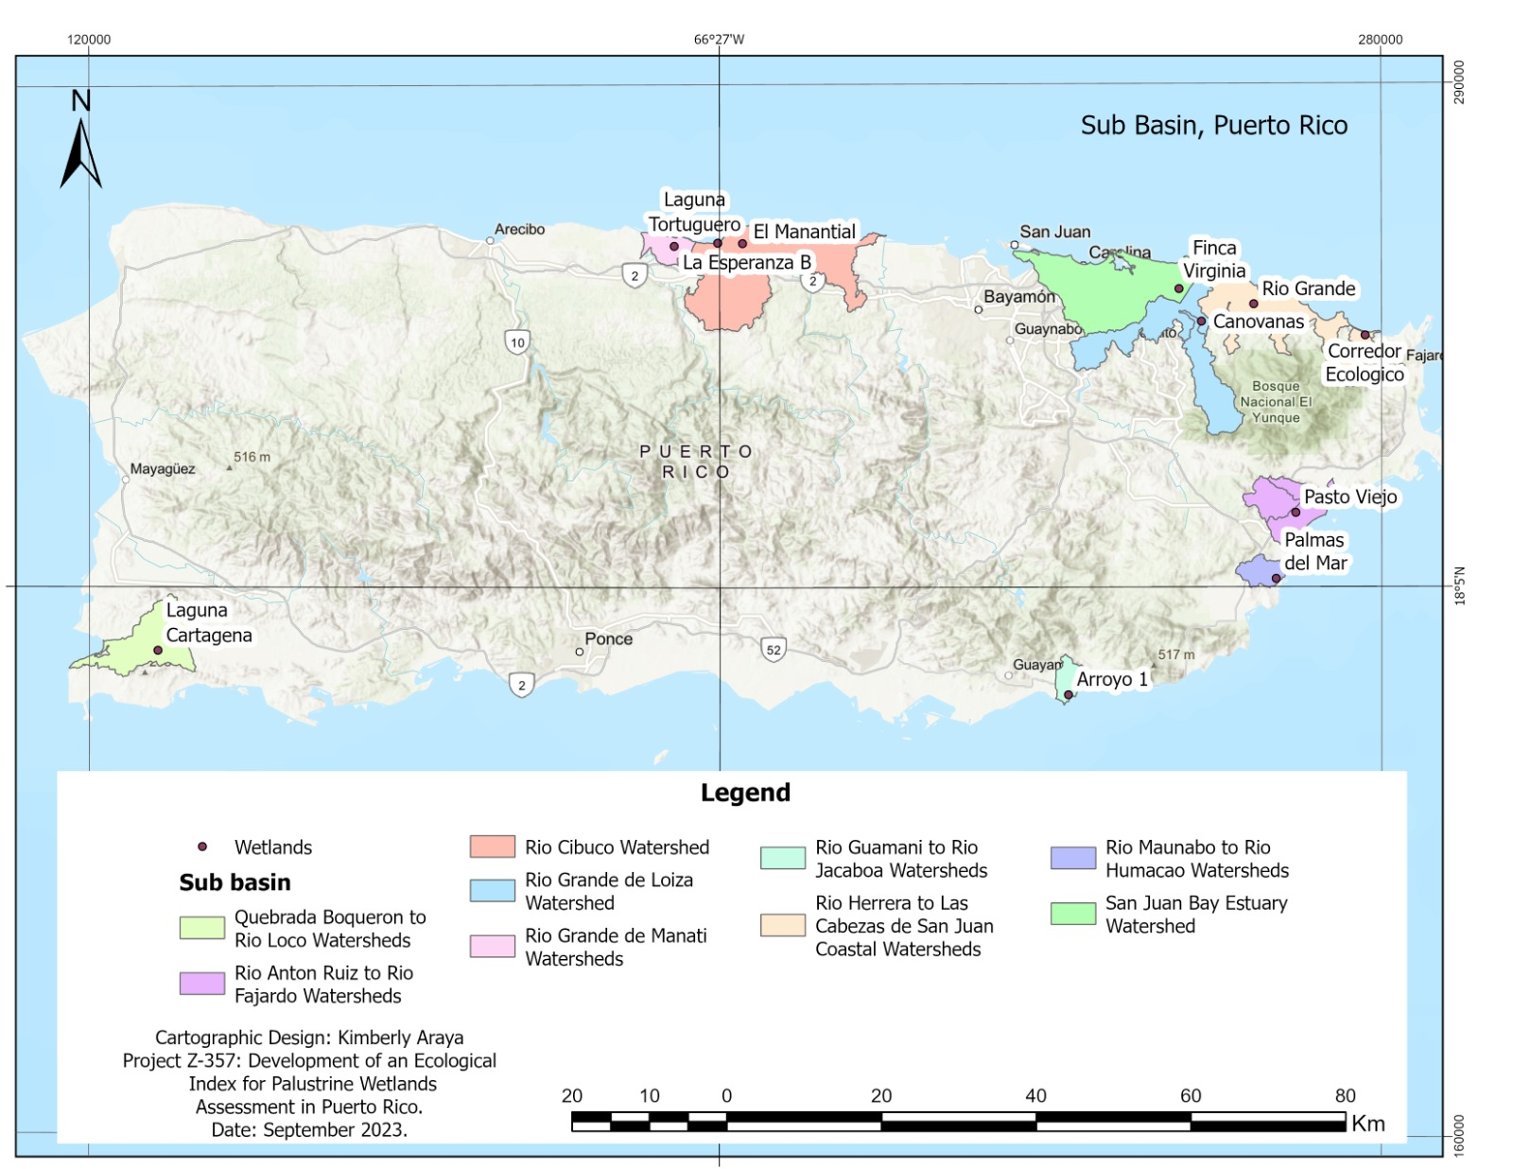

Figure 1. Sub-basins selected as study areas for each wetland.

1. Wetlands indicators
   * 1. NDWI

The NDWI was processed with the Raster Calculator tool from ArcMap 10.8, using Landsat 9 imagery[3]. Bands 4 and 5 were used for GREEN and NIR respectively. Table 2 specifies the satellite image, percentage of cloud cover and the date acquired for each site. All satellite images used were 30x30 m of resolution.

Table 2. Satellite image information for each study site.

|  |  |  |  |
| --- | --- | --- | --- |
| Site Code | Satellite image | Cloud Cover (%) | Date Acquired |
| AR | LC09_L2SP_004048_20221002_20230327_02_T1_SR_B4 LC09_L2SP_004048_20221002_20230327_02_T1_SR_B5 | 14.32 | 2/10/2022 |
| PV |
| CA | LC09_L2SP_004048_20221002_20230327_02_T1_SR_B4 LC09_L2SP_004048_20221002_20230327_02_T1_SR_B5 | 15.55 | 2/10/2022 |
| RG |
| PR3 |
| FV |
| LE | LC09_L2SP_005047_20230113_20230314_02_T1_SR_B4 LC09_L2SP_005047_20230113_20230314_02_T1_SR_B5 | 15.88 | 1/13/2023 |
| EM |
| LT |
| LC | LC09_L2SP_005048_20230708_20230711_02_T1_SR_B4 LC09_L2SP_005048_20230708_20230711_02_T1_SR_B5 | 17.43 | 7/8/2023 |
| PDM | LC09_L2SP_004047_20230615_20230617_02_T1_SR_B5 LC09_L2SP_004047_20230615_20230617_02_T1_SR_B4 | 24.06 | 6/15/2023 |

* + 1. Hydric Soils

The layer of hydric soil was obtained from SSURGO database and clipped with the sub-basins selected for each study site (wetland site).

* + 1. TWI

The TWI was generated using ArcMap 10.8 by ESRI, following the following procedure:

1. DEM: A digital elevation model of 7x7 m for Puerto Rico was used as primary font.
2. Fill: Fills sinks in a surface raster to remove small imperfections in the data. The fill tool corrects the DEM hydrologically.
3. Flow direction: Creates a raster of flow direction from each cell to its downslope neighbor, or neighbors, using D8 methodology rule. The D8 flow method models flow direction from each cell to its steepest downslope neighbor. The D8 flow method uses a dispersive threshold, which establishes the flow accumulation value above which flow dispersion is no longer allowed, routing the flow to the steepest downslope neighboring cell. Its use is opportune on hillslope areas and where the flow is not channelized (Mattivi et al., 2019).
4. Slope: The slope was obtained with Slope tool, which identifies the slope in degrees from each cell of the DEM. The calculation was performed on a projected flat plane using a 2D Cartesian coordinate system.
5. Radians of slope: The slope’s angle in degrees must be transform to slope in radians to obtain tanΦ. The transformation was made using Raster Calculator tool and using the equation:

The result is processed with a conditional in Raster Calculator tool to eliminate undefined cells in the final output (con(slope>0, tan(slope), 0.001).

1. Flow accumulation scaled: The flow accumulation was scaled to the cell size to obtain SCA using the following equation:

1. TWI: The TWI was calculated in Raster Calculator tool with the previous layers using the following equation:
2. Classification of indicators

Created rasters were re-classified in three categories of probability of wetland occurrence: low, medium, and high. The indicators values of each wetland centroid were used as reference to split the range of values (Table 3).

Table 3. Reference values to generate the categories in each wetland.

|  |  |  |  |
| --- | --- | --- | --- |
| Wetland centroid | TWI | NDWI | HS |
| Laguna Tortuguero | 4.840 | -0.344 | 100 |
| Rio Grande | 7.459 | -0.264 | 100 |
| Pasto Viejo | 6.815 | -0.382 | 100 |
| Laguna Cartagena | 12.615 | -0.385 | 98 |
| El Manantial | 7.432 | -0.168 | 100 |
| Finca Virginia | 8.868 | -0.370 | 100 |
| La Esperanza B | 6.257 | -0.423 | 100 |
| Arroyo 1 | 10.760 | -0.341 | 100 |
| Palmas del Mar | 9.952 | -0.851 | 100 |
| Canovanas | 9.893 | -0.333 | 100 |

The values of each indicator for each wetland centroid were used as a validation method for the categories, ensuring that the centroid’s value was contained in the high or medium categories. Table 4 presents the highest number of each category and the reclassified value assigned to that category.

Table 4. Top value of categories and the reclassified value.

|  |  |  |  |  |  |  |
| --- | --- | --- | --- | --- | --- | --- |
| Indicator | TWI | | NDWI | | HS | |
| Category | Top value of each range/ reclassified value | | | | | |
| Low | 5.32 | 1 | -0.7 | 10 | <50 | 100 |
| Medium | 7.66 | 2 | -0.2 | 20 | 50-60 | 200 |
| High | 33.9 | 3 | 0.25 | 30 | >60 | 300 |

The resulting raster product is a raster with the sum of the three indicators as shown in Figure 1. For example, the pixels with a reclassified value of 333 means high TWI, high NDWI and high HS; while the cells with a lowest value or 111 means the opposite, low TWI, low NDWI and low HS.

Figure 2. Result of map algebra with the reclassified values. Laguna Cartagena’s site.

* 1. Reclassification

The previous result was reclassified a second time to distinguish the wetlands pixels from the non-wetlands pixels. The values chosen (in color red) as wetlands were the codification resulting in high or medium combination of the indicators (Table 5).

Table 5. New classification cell values for wetland pixels within the study sites (All values in red are classified as part of the wetland site).

|  |  |  |
| --- | --- | --- |
| OID[4] | Value[5] | Count[6] |
| 0 | 110 | 46 |
| 1 | 111 | 1402 |
| 2 | 112 | 1105 |
| 3 | 113 | 628 |
| 4 | 120 | 3999 |
| 5 | 121 | 175175 |
| 6 | 122 | 151268 |
| 7 | 123 | 117403 |
| 8 | 130 | 1733 |
| 9 | 131 | 34033 |
| 10 | 132 | 79415 |
| 11 | 133 | 69319 |
| 12 | 311 | 111 |
| 13 | 312 | 288 |
| 14 | 313 | 188 |
| 15 | 320 | 237 |
| 16 | 321 | 8287 |
| 17 | 322 | 32106 |
| 18 | 323 | 56796 |
| 19 | 330 | 66 |
| 20 | 331 | 1576 |
| 21 | 332 | 7310 |
| 22 | 333 | 12813 |

All the cells with the values selected were revised according to their next cells to correct any errors that could be generated during reclassification. In some cases, the scale of the hydric soils layer did not match with the other indicators generating values of 1 in cells with high TWI and NDWI, theses cases were corrected one by one.

1. Results

The NDWI indicator worked well to enhance the presence of open water features in remote sensed digital imagery, eliminating soil and terrestrial vegetation(McFeeters, 1996). The NDWI obtained was to -1.233 to 0.254, where the high values represent water features, and the negative values corresponds to soil and terrestrial vegetation (Figure 3).

Figure 3. NDWI obtained for study sites.

The hydric soils classification shows the areas with 60% or more of hydric soils according the SSURGO spatial database (NRCS, 2012) (Figure 4). The HS result is compatible with that obtained with the NDWI, even considering that both layers of information were carried out at different scales.

Figure 4. Distribution of hydric soil in study areas.

The TWI defines the tendency of a cell to receiving or accumulating water. For the sub-basins studied, the higher TWI (>7.29) permits visualize an approximation of the water features that matched with the observed with the NDWI indicator and HS indicator (Figure 5). The representation of the water features is acceptable, with the understanding that a better resolution in the DEM is necessary to derive a more accurate TWI (Wu, 2017).

Figure 5. Obtained TWI for study areas.

The combination of the three indicators by map algebra results in a reliable delineation of wetlands features. The intersection of the variables confirms the presence of wetland in all the study sites (Maps by site, See Appendix 2). This methodology shows that it is possible to map wetland at the watershed level as has been documented in this project. The result obtained from the reclassification matched in 96% of the cases with the U.S. National Wetlands Inventory.

References

Bian, L., Melesse, A. M., Leon, A. S., Verma, V., & Yin, Z. (2021). A deterministic Topographic Wetland Index based on LiDAR-Derived DEM for delineating open-water wetlands. *Water, 13*, 2487.

Carter, V. (1999). Technical aspects of wetlands: Wetland hydroloy, water quality, and associated functions. *United States Geological Survey Water Supply Paper* .

Duda, T., & Canty, M. (2002). Unsupervised classification of satellite imagery: choosing a good algorithm. *International Journal of Remote Sensing, 23*, 2193-2212.

Lang , M., McCarty, G., Oesterling, R., & Yeo, I. (2013). Topographic Metrics for improved mapping of forested wetlands. *Wetlands, 33*, 141-155.

Lang, M., & McCarty, G. (2009). Lidar intensity for improved detection of inundation below the forest canopy. *Wetlands, 29*, 1166-1178.

Mattivi, P., Franci, F., Lambertini, A., & Bitelli, G. (2019). TWI computation: a comparison of different open source GISs. *Open Geospatial Data, Software and Standards*, 1-12.

McFeeters, S. (1996). The use of the Normalized Difference Water Index for delineation of open features. *International Journal Remote Sensing, 17*, 1425-1432.

NRCS. (2012). *Hydric Soils*. Retrieved from Natural Resources Conservation Service : https://www.nrcs.usda.gov/conservation-basics/natural-resource-concerns/soil/hydric-soils#criteria

Ozesmi, S. L., & Bauer, M. E. (2002). Satellite remote sensing of wetlands. *Wetlands Ecology and Management, 10*, 381-402.

Sorensen, R., Zinko, U., & Seibert, J. (2006). On the calculation of the topographic wetness index: evaluation of different methods based on field observations. *Hydrology and Earth System Sciences*(10), 101-112.

U.S. Army Corps of Engineers. (2010). *Wetland hydrology criteria and field indicators.* Mississippi: U.S. Army Corps of Engineers.

USGS. (2023, August 17). *Earth Explorer*. Retrieved from Earth Explorer: https://earthexplorer.usgs.gov/

Wu, Q. (2018). GIS and Remote Sensing Applications in Wetland Mapping and Monitoring. *Comprehensive Geographic Information Systems*, 140-157.

1. The Normalized Difference Vegetation Index (NDVI) was not considered as an indicator in this exercise because did not represent any differences of vegetation between and inside the sites. The resolution used don’t permit visualize differences between specific vegetation from each wetland category.
2. Hydrographic units, HU_12 detailed according to the US Geological Survey, 2019.
3. (USGS, 2023).
4. OID = ObjectID default field generated by ArcMap in attributes tables of rasters.
5. Value = Classified value.
6. COUNT = Count of pixels with a specific value.